WEBSITE TRAFFIC ANALYSIS

PROJECT TITLE: Website Traffic Analysis

PHASE 5: Project Documentation & Submission



**INTRODUCTION**

Website traffic analysis involves collecting and analyzing data about visitors to your site and their actions once they reach it. This information is vital for marketers to implement effective tactics that optimize website traffic and improve the conversion rates.

The amount of traffic is no longer the only metric used to verify a business’s success. That’s why we have comprehensive website traffic analysis tools to help us make accurate assessments.

**How Do Website Traffic Analysis Tools Work?**

**Bounce rate:** The proportion of visitors who landed at any of your webpages and then left without further interacting with the site

**Conversion rate:** The percentage of visitors that interact with a call to action on the website (such as submitting a form or purchasing ,a product). This interaction is known as [a conversion](https://kinsta.com/blog/conversion-rate-optimization-tips/).

**Unique visits:** Counts only a person’s first visit, allowing you to separate potential clients from loyal user

**Exit pages:** Identifies the pages from which each visitor leaves your website.

**WORKING OF WEBSITE TRAFFIC ANALYSIS**



**Step 1: Identify Your Data Sources**

**The first step is to find out what’s out there on your network. You can’t analyze and monitor something if you don’t know it exists. There are two parts to this step.**

**Determine Data Source Types**

**You’ll need to identify and categorize the types of sources you can collect data from. There are applications, desktops, servers, routers, switches, firewalls, and more. Each of these can provide**[**various metrics**](https://stackify.com/metrics-monitoring-choosing-the-right-kpis/)**you can collect for analysis.**

**Decide Methods of Identification**

**Next, you’ll need to determine the best methods you can use to identify your data sources. You can use a manual or automated approach. The manual approach involves sifting through topology maps and other documentation, but they quickly go stale. So consider the automated method with**[**application and network discovery**](https://stackify.com/what-is-application-discovery-and-dependency-mapping/)**. Common auto-discovery methods include using SNMP, Windows Management Instrumentation (WMI), flow-based protocols, and transaction tracing. Doing this now will later help you find application and network dependencies and maximize infrastructure visibility.** 

**Step 2: Determine the Best Way to Collect from Data Sources**

**The next step is to find out the best way to collect the data you need from your data sources. There are broadly two ways to collect network traffic data: with and without agents.**

**Agent-Based Collection**

**Collecting data using an agent involves deploying software on your data sources. Agents can collect information about running software processes, system resource performance, and inbound/outbound network communications. While agent-based collection can provide very granular data, it can also create processing and storage issues.**

**Agentless Collection**

**Collecting data without agents involves using processes, protocols, or APIs already supported by your data sources. Agentless collection includes methods such as SNMP**

**Step 3: Determine Any Collection Restrictions**

**Once you know your data sources and the best way to extract network traffic data from them, it’s tempting to just get going. But your organization likely has rules and restrictions on what and how infrastructure is managed. Not determining any of these requirements beforehand will adversely affect your ability to analyze network traffic.**

**So, make sure to find out if there are any ports you need to open up for collection, for example. Be sure to find out if departmental approval is required before data collection can begin. This can help you break down silos by collecting data from other parts of the network.**

**And think about the industry your organization is in. Highly regulated industries like healthcare or finance may not allow you to collect certain types of data or may require you to store data for a longer period. Having more historical data can be helpful for network traffic analysis, but this takes up storage. So be aware of any rules restricting or governing data collection. Network devices and WMI on Windows servers. Syslog enabled on firewalls helps identify security events, and flow-based protocols help identify traffic flows. Agentless collection doesn’t always produce data as granular as agent collection, but it works well enough to give you the user and system data you need to properly analyze network traffic.**

**Step 4: Start a Small and Diverse Data Collection**

**The next step is to enable your data sources for collection. The key here is to start small with a diverse set of data sources, especially if you run a large network. This will help identify issues with any systems before you expand your reach across the network. The last thing you want is to collect data from all your Windows servers, for example, and then find out that certain groups of servers keep crashing. So, start small with a diverse group and expand from there.**

**DATA INGEST**

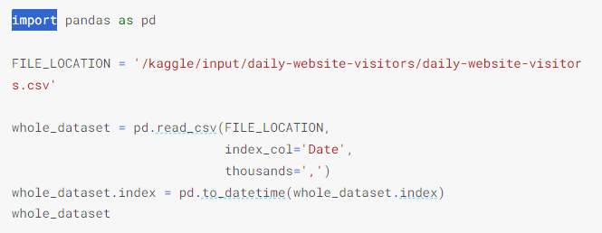

**OUTPUT**

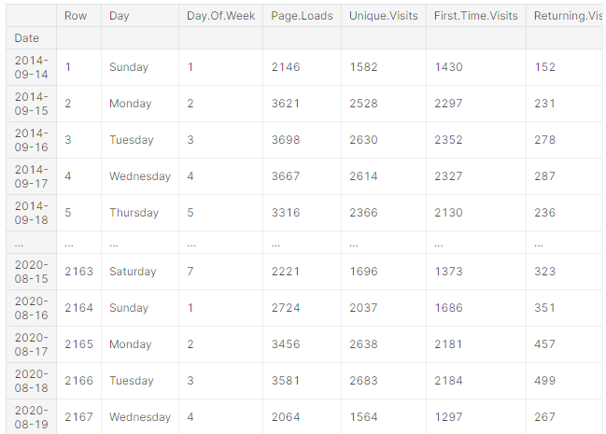

## **What Do Website Traffic Analysis Tools Measure?**

Website traffic analysis tools measure the performance of your website using the aforementioned metrics. The data they gather allows you to compare your performance to your competitors’ and make sure you’re on the right track.

The key measurements, however, are centered around unique visitors (UVs), page views, and traffic curves.

Monitoring unique visitors will help you identify the number of individuals who viewed one of your website’s pages at least once a month.

With traffic views, the duration of every session genuinely matters depending on the type of website you’re running. For example, it would be a critical indicator for content-generating websites.

As for traffic curves, they help determine peak audience activity times. Consequently, you’d be able to learn at what times you can expect traffic surges so you improve your strategy.

**Preprocessing the data**

* Target Attribute: **Returning Visits** We shall predict the **Returning Visits** given past data.
* 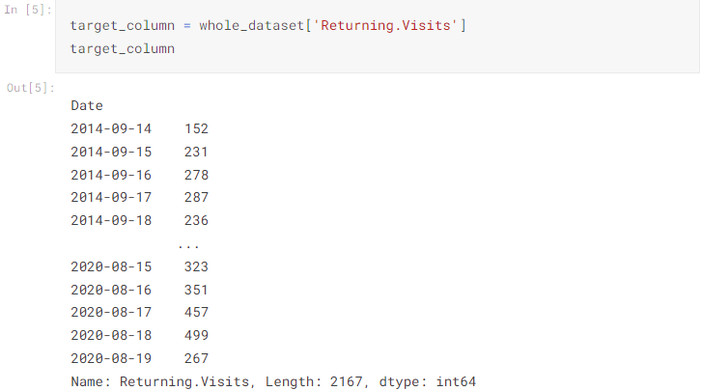

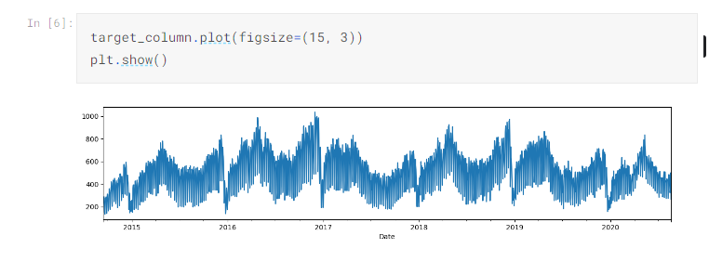

Feature engineering is a crucial step in website traffic analysis as it involves transforming raw data into meaningful features that can be used in machine learning algorithms. These features help in understanding the behavior of website visitors, identifying patterns, and making data-driven decisions. Here are some examples of feature engineering techniques for website traffic analysis:

**1. Time-based features:** Extract features related to time, such as hour of the day, day of the week, or month. These features can help identify patterns or trends in website traffic based on specific time periods.

**2. Visitor segmentation**: Group website visitors based on certain characteristics, such as demographics, location, device type, or referral source. This segmentation can provide insights into different user behavior patternsand preferences.

**3. Page-specific features:** Analyze the characteristics of specific pages on the website, such as page load time, number of images or videos, or the presence of specific elements like forms or call-to-action buttons. These features can help evaluate the impact of page design and content on user engagement.

4. Conversion funnel features: Track the progression of visitors through the conversion funnel, from initial landing page to final conversion event. Capture metrics like time spent on each page, number of interactions, or drop-off rates at different stages. These features can reveal bottlenecks or areas of improvement in the conversion process.

5. Referral features: Analyze the source of website traffic, including direct traffic, organic search, social media, or paid advertisements. Create binary features to indicate if a visitor came from a specific referral source or group multiple referral sources into categories. This can help identify the most effective channels for driving traffic to the website.

6. Engagement features: Measure user engagement by capturing metrics like session duration, bounce rate, or average number of pages viewed per session. These features can provide insights into user satisfaction and interest in the content.

7. Geo-location features: Use IP address data to extract features related to visitor location, such as country, region, or city. This information can be helpful in understanding geographical trends in website traffic and tailoring content or marketing efforts accordingly.

8. Behavior-based features: Analyze user behavior within the website, such as click patterns, scroll depth, or time spent on specific sections. Identify features that indicate user engagement or indicate potential areas of friction in the user experience. Remember that feature engineering should be aligned with your specific goals and the nature of your website. It requires domain knowledge and an iterative process of experimentation and refinement.

**COMPUTE TRAIN AND TEST BOUNDARIES**

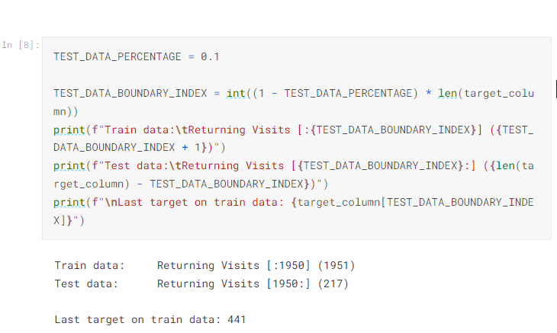BASELINE MODEL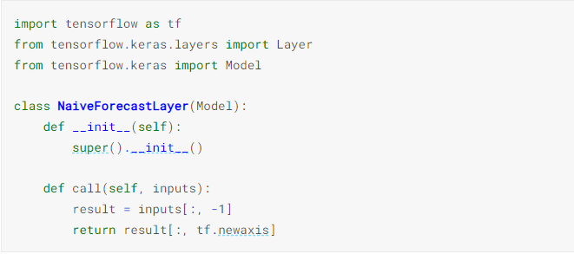

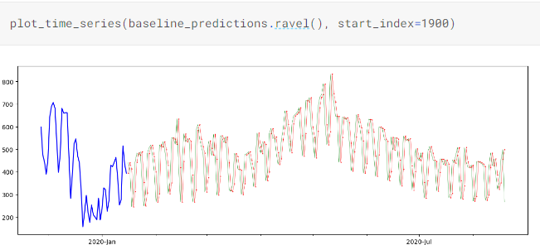

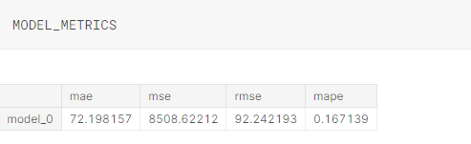

REQUIEREMENT MODEL

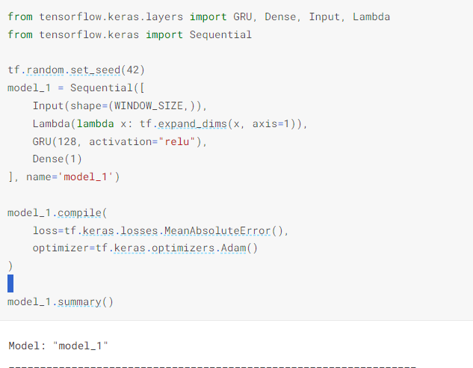

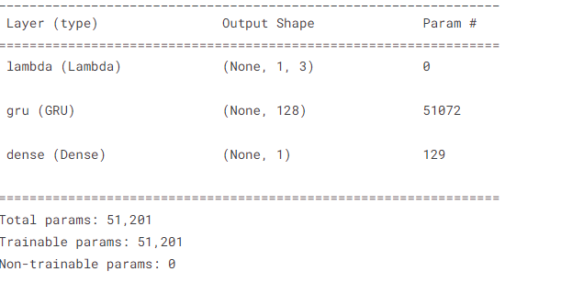

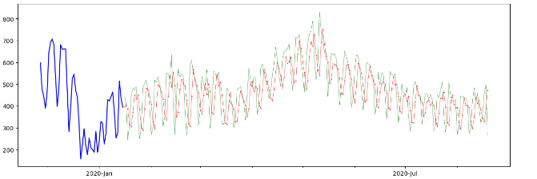

MULTI INPUT MODEL

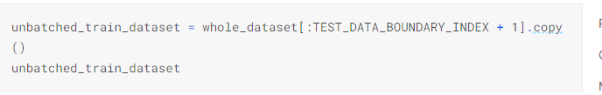

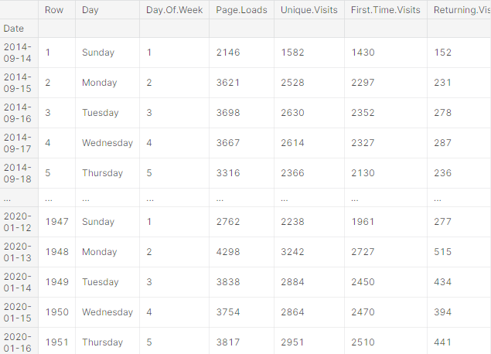

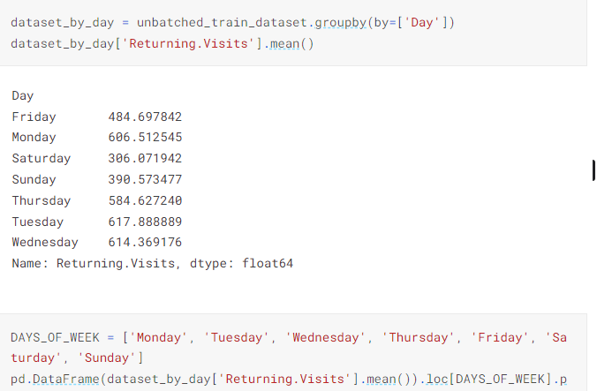

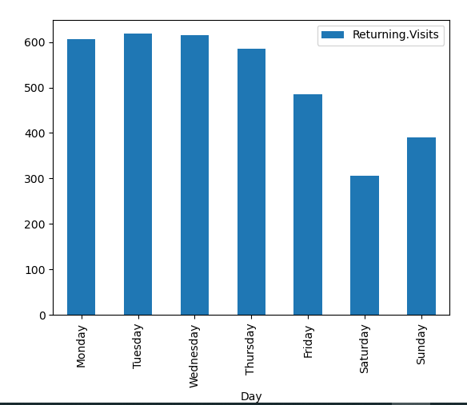

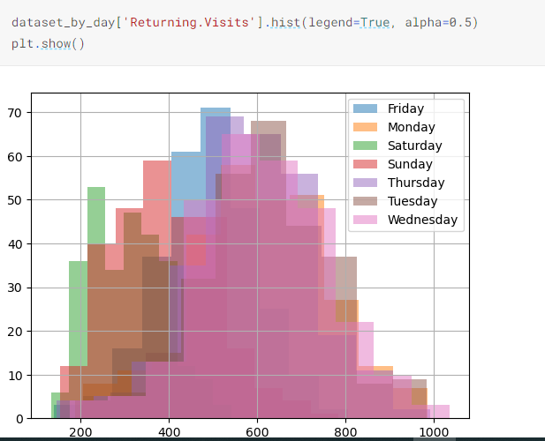

ENSEMBLE METHODS

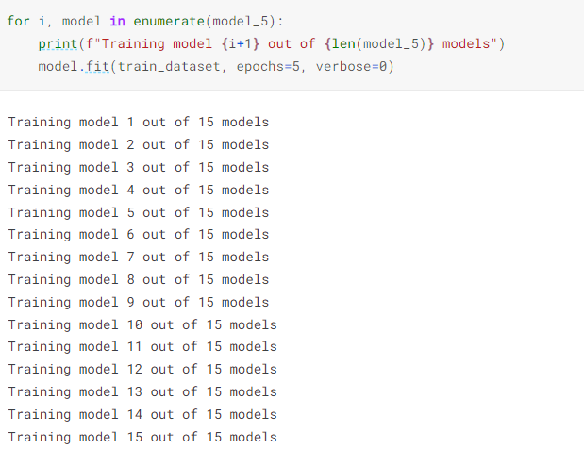

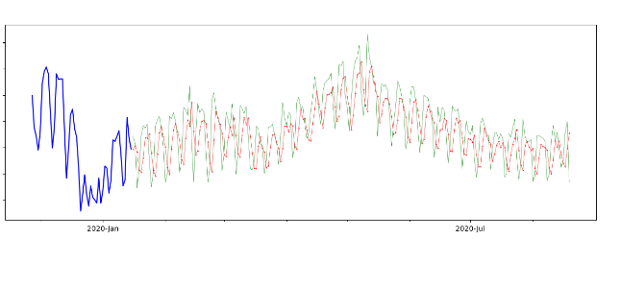

**Benefits of Website Traffic Analysis**

Website traffic analysis tools play a critical role in helping you personalize your B2B strategy to match your clients’ needs and learn more about your industry rivals.

Here are the top three advantages of employing these tools.

**In-Depth Insight into Website Traffic**

Website traffic analysis reveals the different sources of online traffic, allowing you to determine which marketing model produces positive business outcomes. You’ll also be able to track the progress of both organic and sponsored traffic in real time.

**Improving User Experience**

Your target audience is your source of profit. It’s essential to develop a deep understanding of your intended clientele in order to market your products or services successfully.

Website traffic analysis tools help you identify the types of users that visit your website, their interests, and every action they take on your web pages. As a result, you’ll discover how to improve user experience (UX) and get a clearer picture of how well your website is performing.

Consider this: Do you actually reach your target audience? Which pages do they stay on the most? Do you have any undetected technical problems that drive users away? Do you meet your ROI objectives? How well are you achieving your conversion goals?

Traffic analysis tools can also help you discover whether you’re using a trusted web host that won’t negatively impact the availability or load times of your pages, which can destroy your brand identity.

**Boost SEO Rankings**

Many website traffic analysis solutions include search engine optimization (SEO) tools for enhancing your site’s ranking on search engines, especially Google. These features let you see how keywords are affecting your SEO and even how much traffic you’re receiving from social media platforms.

With the aid of these checkers, you can make precise modifications to improve your SEO status and get recognized on Google’s first pages.

**Program for web Traffic Analysis**

**import pandas as pd**

**import matplotlib. Pyplot as plt**

**import ploty.express as px**

**import ploty.graph_object as go**

**from statsmodels.tsa.seasonal import seasonal_decompose**

**from statsmodels.graphics.tsaplots import plot_pacf**

**from statsmodels.tsa.arima_model import ARIMA**

**import statsmodels.api as sm**

**data=pd.read_CSV ("website. CSV")**

**print (data.head())**

**print (data.tail())**

**data ["Data"]=pd.to_datetime (data["Date"],format = "%d/%m%/y")**

**print (data.info ())**

**plot.style.use ('five thirty eight')**

**plot.figure(figsize=(15,10))**

**plot.plot(data["Date"],data ["Views"])**

**plot.title("Daily Traffic of website. com")**

**plot.show()**

**from statsmodels.tsa.seasonal import seasonal_decompose**

**result = seasonal_decompose (data["Views"], model = 'multiplicative', extrapolate_trend = 'freq', period=30)**

**fig = ply.figure()**

**Fig=result. plot ()**

**Fig.set_size_inches (15,10)**

**Pd.plotting.autocorrelation_plot(data["Views"])**

**p,d,q=5,1,2**

**Model=sm,tsa,states pace.SARIMAX (data['Views'],order=(p,d,q),seasonal_order=(p,d,q,12))**

**Model=model.fit()**

**Print (model.summary())**

**Prediction=model.predict (len(data),len(data)+50)**

**Data ["Views "].plot(legend=True,label="Training Data",figsize=(15,10))**

**Predictions.plot(legend=True,label="Predictions"**

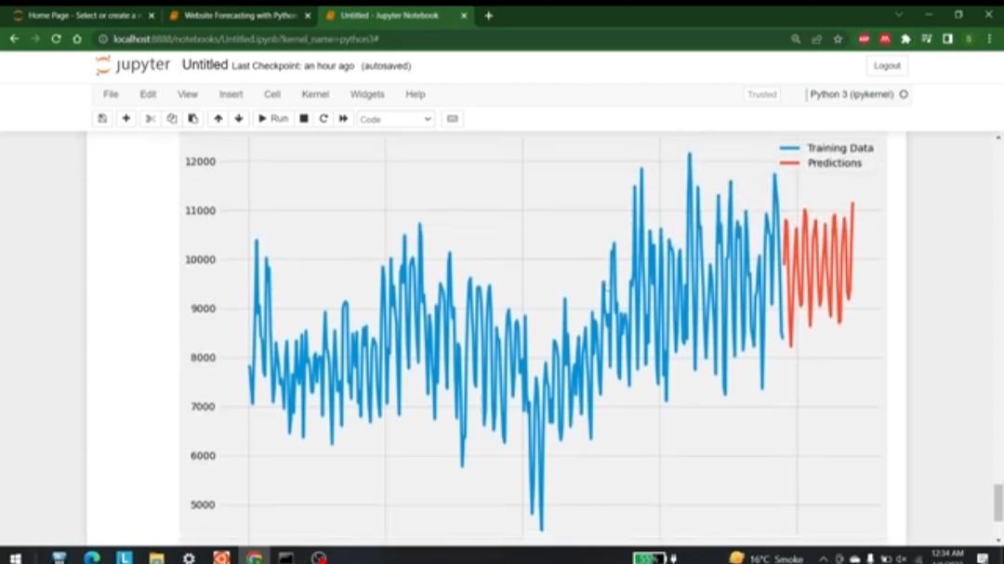

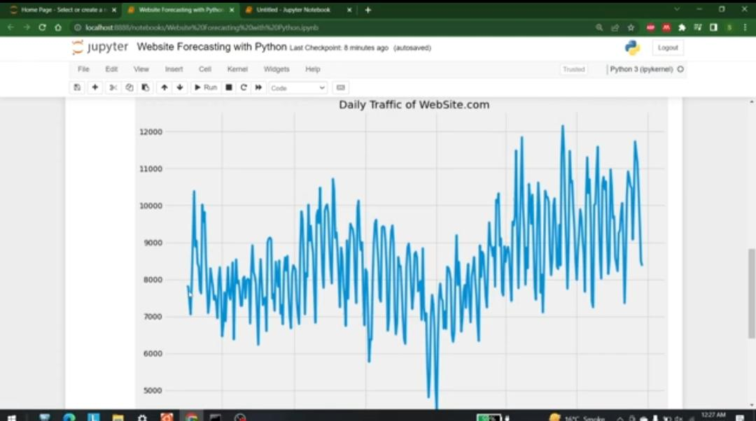

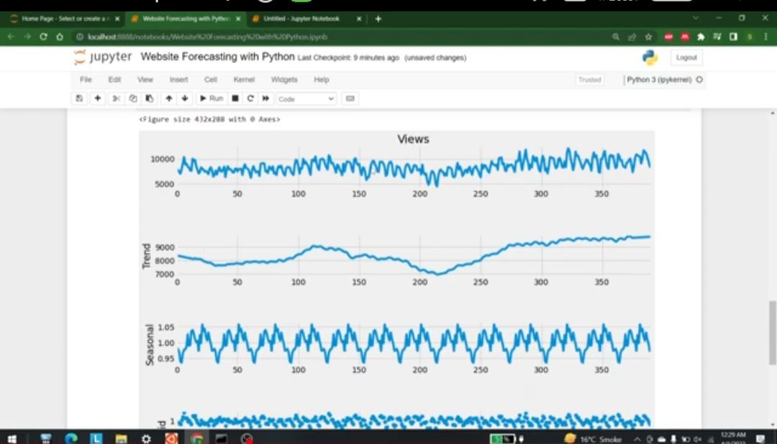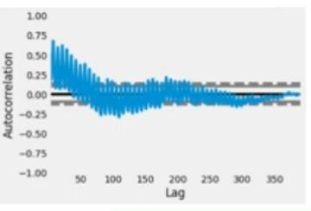

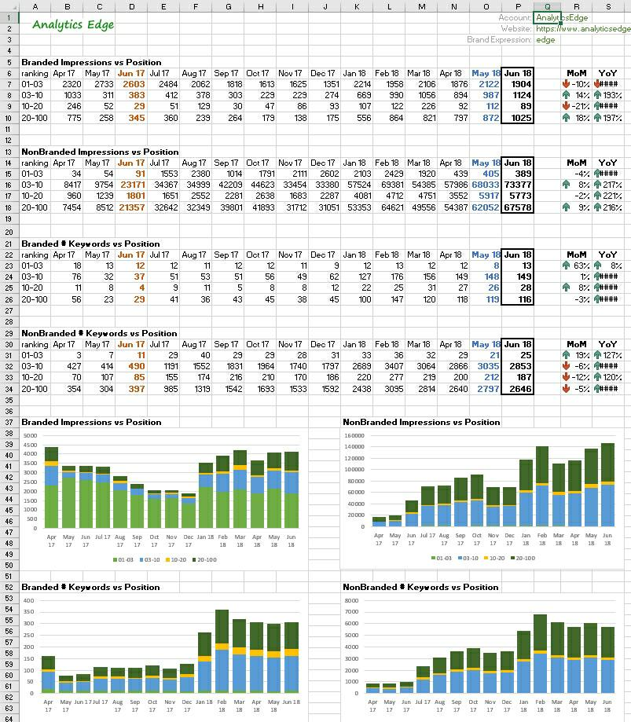

**Conclusion**

Analyzing website traffic allows businesses to gain a comprehensive understanding of their online presence and performance. By examining the number of visitors, page views, and session durations, businesses can gauge the level of interest and engagement with their content. The website traffic analysis project has provided valuable insights into the performance and user engagement of the website. Through data collection, analysis, and interpretation of key metrics, we have gained a deeper understanding of visitor behavior, which can inform strategic decisions and improvements. This project highlights the importance of ongoing traffic analysis to optimize the website, enhance user experience, and ultimately achieve our objectives. As we continue to refine and adapt our strategies, the knowledge gained from this analysis will be instrumental in driving success in the digital landscape.